Dissertation Proposal

Programme: MSc in Computer Science Year: 2022

Student Name: Alexandra Han Term: 3

Student ID: u2161188

Title of the dissertation: Human Activity Recognition using Deep Learning on mobile collected data

Introduction

It is widely believed that Human Activity Recognition (HAR) sector has significant importance in the future development of many different fields like medicine, sociology, human-computer interaction, intelligent homes, security surveillance and others. HAR can be conceivable with the support of smartphones, sensors, video cameras or images. According to Cook, ‘There are mainly two types of HAR: video-based HAR and sensor-based HAR.’ (Cook, et al., 2013) While video-based HAR investigates human motion from videos/images, the sensor-based HAR concentrates on smart sensor motion data. There are four different types of sensors that can be utilised to collect data. The ‘body-worn sensors’, like accelerometer, gyroscope, and magnetometer, are the most frequent. They can be placed in watches, bands, smartphones, etc. The ‘object sensors’ are generally set on objects to monitor their motions where the signals are used as input for data. The ‘Ambient sensors’ like radar, temperature, sound, or pressure sensors are placed in the user’s surroundings. They represent the activity (movement) of a human in his surroundings. The ‘Hybrid sensors’ is used as a collaboration of different sensors for higher accuracy. (MUNOZ-ORGANERO, 2019)

Compared with classical methods, the Deep Learning approach is optimal for Human Activity Recognition. Deep Learning techniques are mainly preferred due to low human interaction needs. ‘The features can be learned automatically through the network instead of being manually designed…can also extract high-level representation in the deep layer, which makes it more suitable for complex activity recognition task.’ (Wang, et al., 2017)

This document proposes the investigation of Human Activity Recognition using smartphones, with a deep learning method on the ‘ml/machine-learning-databases/00240’ (UC Irvine) dataset combined with a dataset collected with my smartphone for training and testing proposes while adding a literature review on the latest (2021-2022) investigations on HAR.

Research Area

According to the study made by Yan, Liao, and Huang (Yen, et al., 2020) on recognising six human activities (walking, walking upstairs, walking downstairs, sitting, standing, and lying), a percentage of 95.99% and 93.77% accuracy was obtained. They used their dataset, specially collected for this study and another dataset provided by the University of California. Both datasets have been cumulated with the aid of android smartphones (Samsung Galaxy S2) by 30 humans, recording data from accelerometer and gyroscope sensors. Furthermore, the Inertia sensors were used to collect data on three-axis angular velocity and three-axis acceleration. Finally, they used a deep learning algorithm and Convolutional Neural Networks for future extraction and classification. Also, they realised that by removing the pooling layer, the training time would also reduce and so the accuracy. Still, after 350 epoch training, they obtained a higher accuracy but not higher than 97%.

Dewi and Chen found an accuracy of 98.16% in a quite similar study focusing on the same six types of human activities recognition. (Dewi & Chen, 2019) Compared with the study made by Yan, Liao, and Huang, they have used four different classification methods to gather a higher accuracy. Random Forest, Support Vector Machines, K-Nearest Neighbors and Linear Discriminant Analysis were applied using different features. The highest accuracy was obtained with the Random Forest classifier. The second scope of this study was to find the most significant variables for data classification by using the Boruta algorithm and Recursive Feature Elimination. Caret Package was applied for regression and classification training. They needed to restrain the features but keep the essential ones for optimal accuracy. The analysis was based on the same dataset provided by the University of California.

Expected Practical Element Output

This study aims to investigate HAR using Machine learning. The six daily human activities to be classified are: sitting, standing, walking, walking downstairs, walking upstairs, and sleeping. The main objective is to increase the accuracy while exploring the CNN method. Therefore accelerometer and gyroscope sensors will be used for collecting data on a smartphone (iPhone instead of android) using the MATLAB phone app. Also, an open-source dataset has been selected so that both datasets will be synthesised, and 70% of it will be used for training proposes, while the rest of 30% for validation and testing.

This research proposal is to fit the selected data to the Deep Learning algorithm - Convolutional Neural Network (CNN); using different training parameters to achieve a high level of accuracy. The features will be automatically extracted and learned from the input data. A convolutional layer, Pooling layers and a Fully Connected layer will be created. Critical analyses will be done on the training process and result obtained. Graphs and numerical explanations will be provided on the results.

As a second objective, this study will maintain the pooling layer, even when the training time is increased, for testing if the accuracy of results will improve after less than 350 epochs.

Required Resources, Prerequisite Knowledge/Skills Required

The chosen open-source dataset is recorded by thirty humans wearing smartphones on their waist while doing regular daily movements. The smartphones had inertial sensors enclosed. The movements were videotaped in order to label the data while the inertial signals were pre-processed. (Reyes-Ortiz, et al., 2012) Data analysis will be done for the second set of data after collection.

The code will be written in MATLAB using the MathWorks-MATLAB programming platform.

Equipment requested for this experiment is an iPhone to collect data; a computer with Microsoft Windows 10, Processor Intel (®) Core™ i7-10510 CPU @ 1.80GHz 2.30GHz, 16.0 GB;

Skills required for completing this work are MATLAB knowledge, Machine Learning Onramp, Image processing, Deep Learning onramp and mathematics. In addition, basic programming skills and computer science are mandatory.

It is possible but unlikely that the project will not achieve its objectives due to the system’s inability to train the network on an extensive dataset within the specified period of time.

Project Plan – Gantt Chart

Figure 1 illustrates the timetable, expense estimate and capabilities of this research toward pursuing its goals.

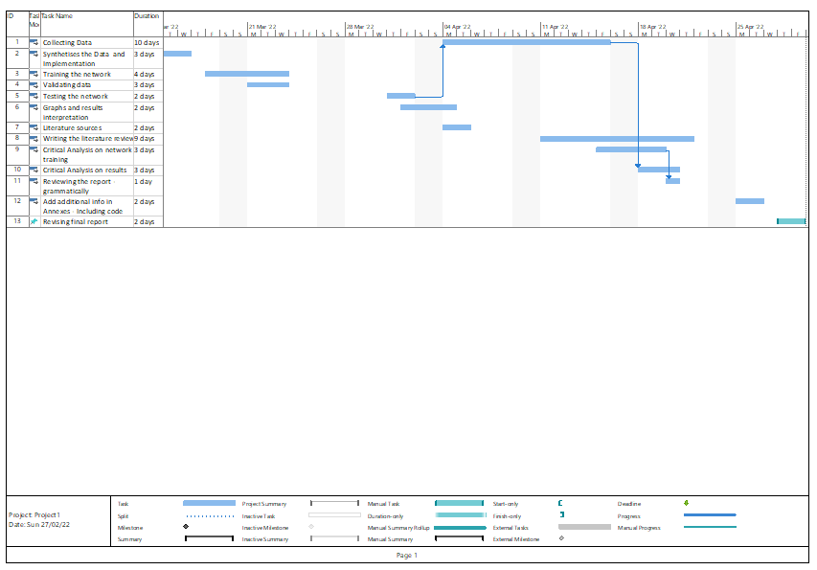

Figure 1 - Gantt Chart

This research will be summarised in a detailed report of the literature review and experiment, including the afferent code annexed, to be completed by the 10th of May 2022.

For printing the necessary documents, the cost is estimated at 15 GBP. As all the literature can be found online or in UEL Library, no extra costs are expected.

I am a postgraduate student of MSc Computer Science, with no I.T. background. However, as a result of my previous modules studies at the University of East London this year, I am better prepared to handle and succeed with this project. In addition, I completed a similar (fruit image classification) project based on transfer learning for my Artificial Intelligence module, and HAR’s research will be a challenging experience for me.

HAR is essential in healthcare, especially for monitoring older adults' movements. A higher degree of accuracy is crucial when developing future projects/apps in other fields as well.

This document is a proposal for my dissertation research based on HAR using Machine Learning for detecting six different daily activities using CNN on open-source data synthesised with my data, with the primary objective of increasing the accuracy of the results. The final report will include a literature review on similar research and the experimental code with the annexed graphical and numeral results.

# References

Cook, D., K.D., F. & N.C., K., 2013. Transfer Learning for Activity recognition : A Survey.. *Knowledge and information system,* 36(12), pp. 537-556.

Dewi, C. & Chen, R.-C., 2019. *Human Activity Recognition Based on Evolution of Features Selection and Random Forest.* Bari, Italy, Man and Cybernetics (SMC).

Huang, W. et al., 2021. Shallow Convolutional Neural Networks for HumanActivity Recognition Using Wearable Sensors. *IEEE TRANSACTIONS ON INSTRUMENTATION AND MEASUREMENT,* 70(2510811), pp. 01-11.

MUNOZ-ORGANERO, M., 2019. *ieeexplore.ieee.org.* [Online]   
Available at: https://ieeexplore.ieee.org/document/8731887  
[Accessed 18 02 2022].

Reyes-Ortiz, J. et al., 2012. *Human Activity Recognition using smartphones.* [Online]   
Available at: https://archive-beta.ics.uci.edu/ml/datasets/human+activity+recognition+using+smartphones  
[Accessed 24 02 2022].

Wang, J. et al., 2017. Deep Learning for Sensor-based Activity Recognition: A Survey. *ELSEVIER Pattern Recognition Letters,* 2(14), p. 2.

Yen, C.-T., Liao, J.-X. & Huang, Y.-K., 2020. Human Daily Activity Recognition Performed Using Weareble Inertial Sensors Combined With Deep Learning Algorithms. *IEEEAccess,* 8(10), pp. 174105-174114.